**Name**

Peter Šťastný

**Game name**

Cheese Rush

**Game screenshot**

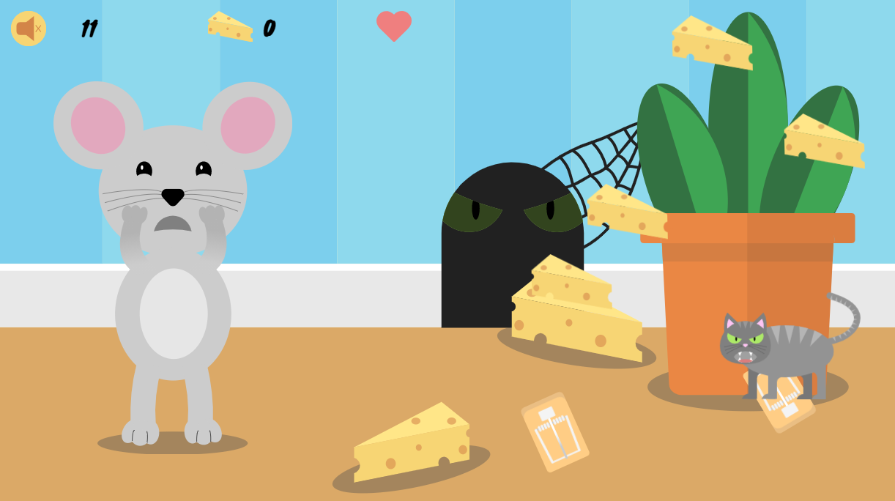

**Game idea**

In cheese Rush, Mia the mouse needs your help catching cheese so as not to go hungry. You must avoid the mousetraps and an angry cat that is lurking around. Collect the required amount of cheese before the time runs out!

**Sketch of the game**

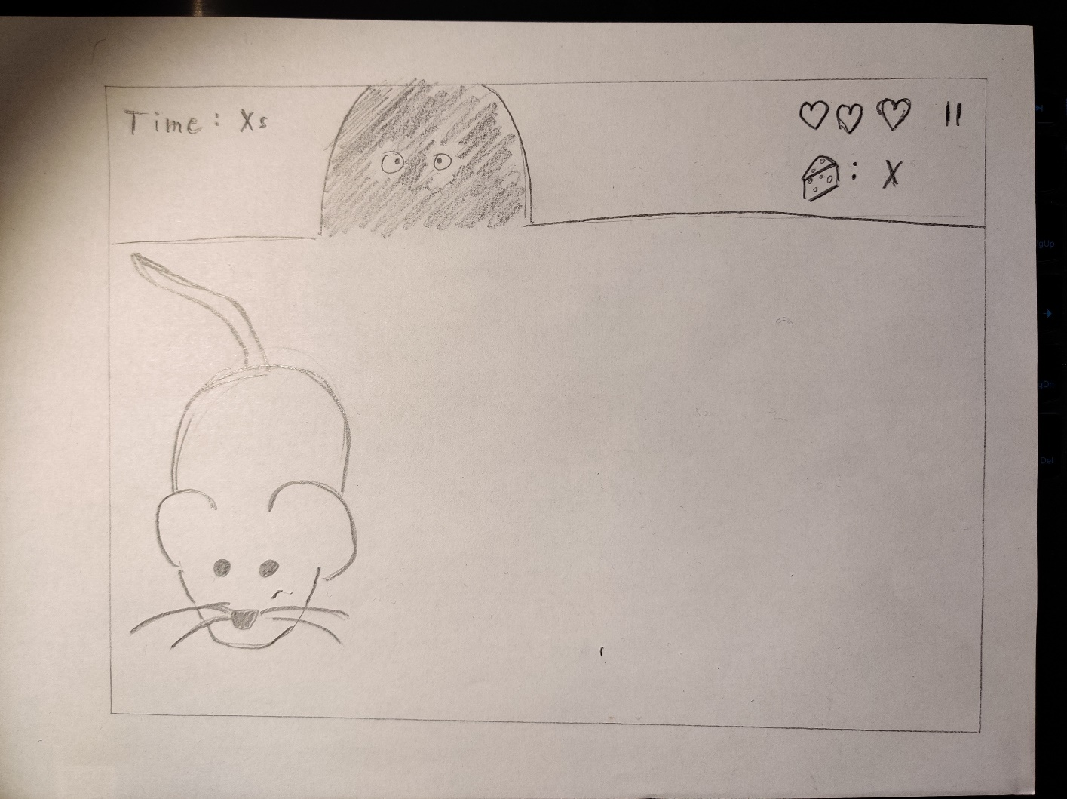

**Link to paper prototype video**

<https://youtu.be/c6ZlQDLhNAI>

**Activity diagram**

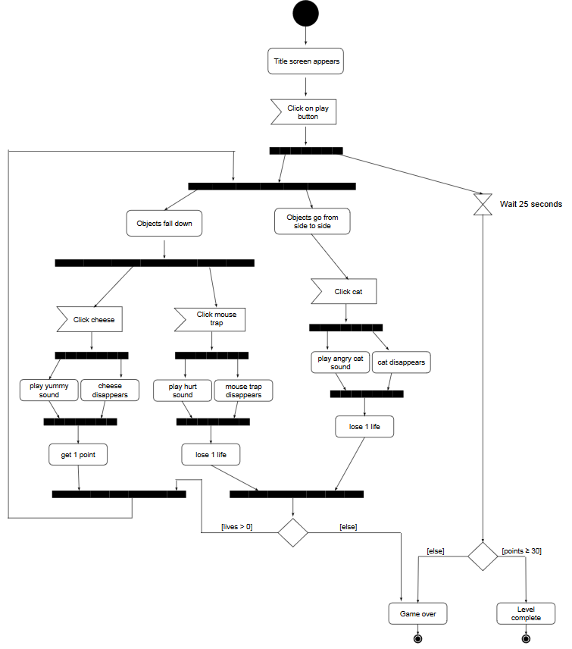

**Style tile**

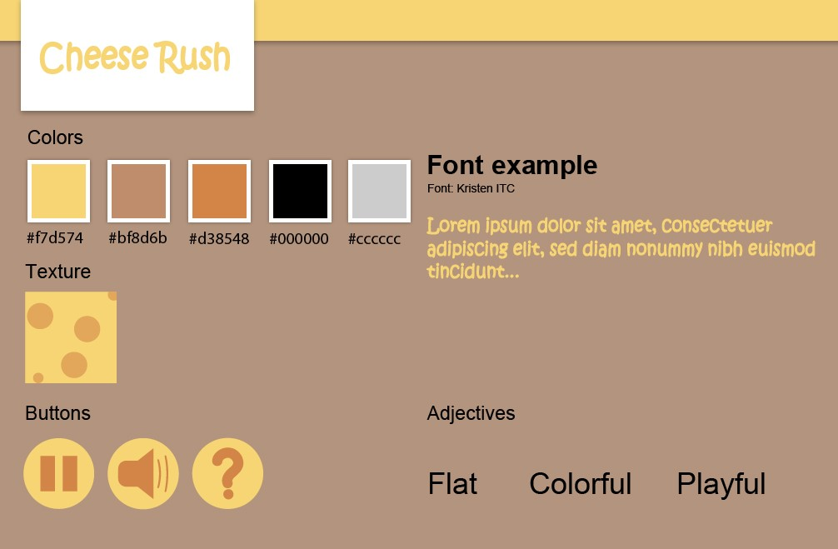

**Sketches**

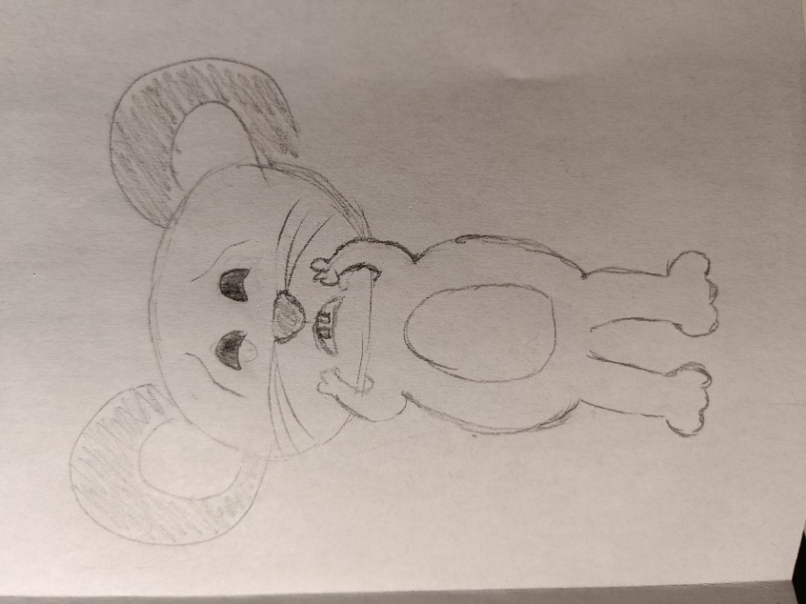 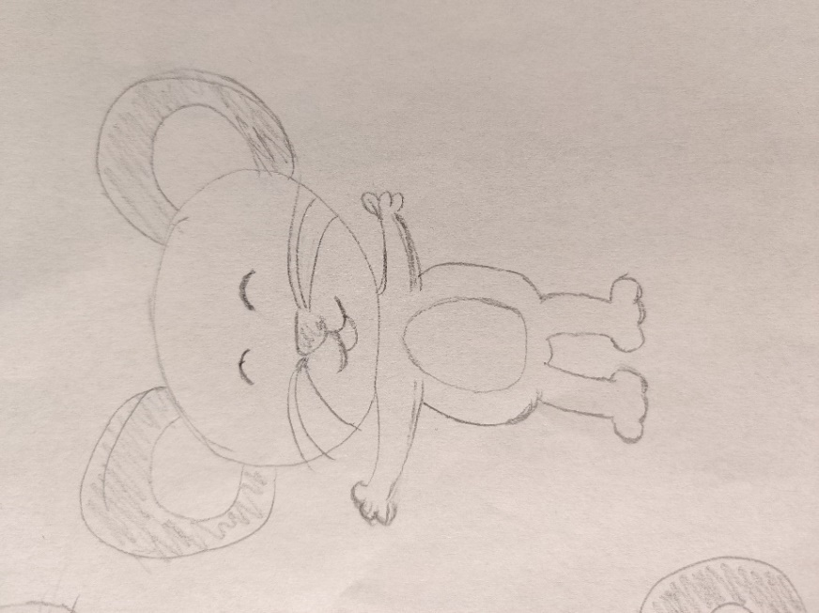

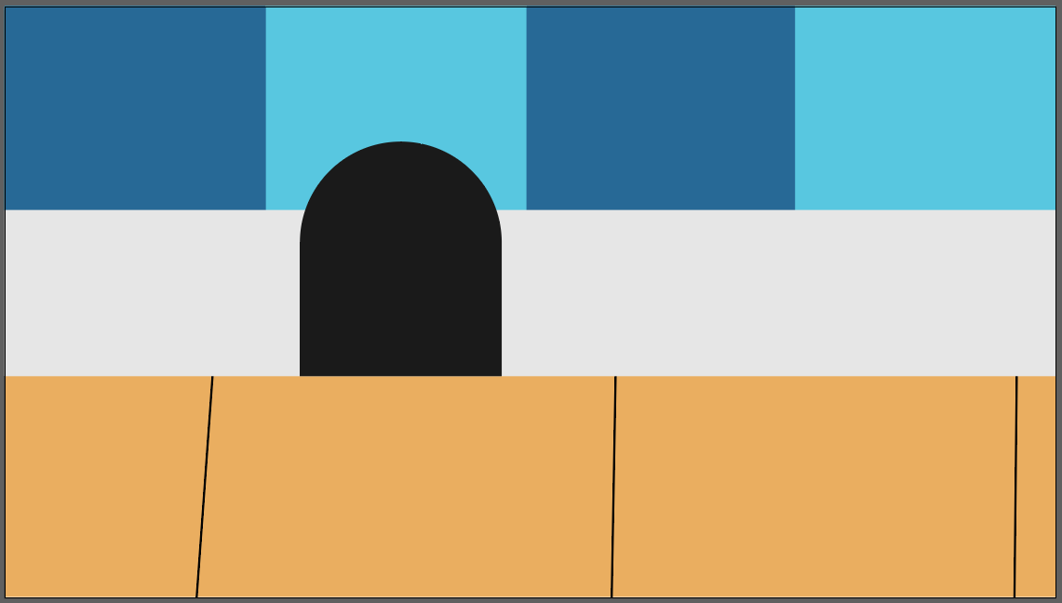 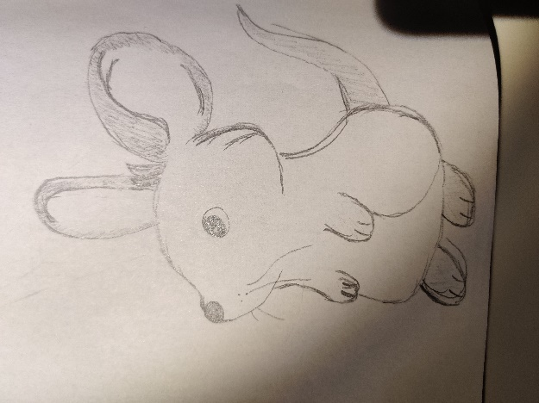

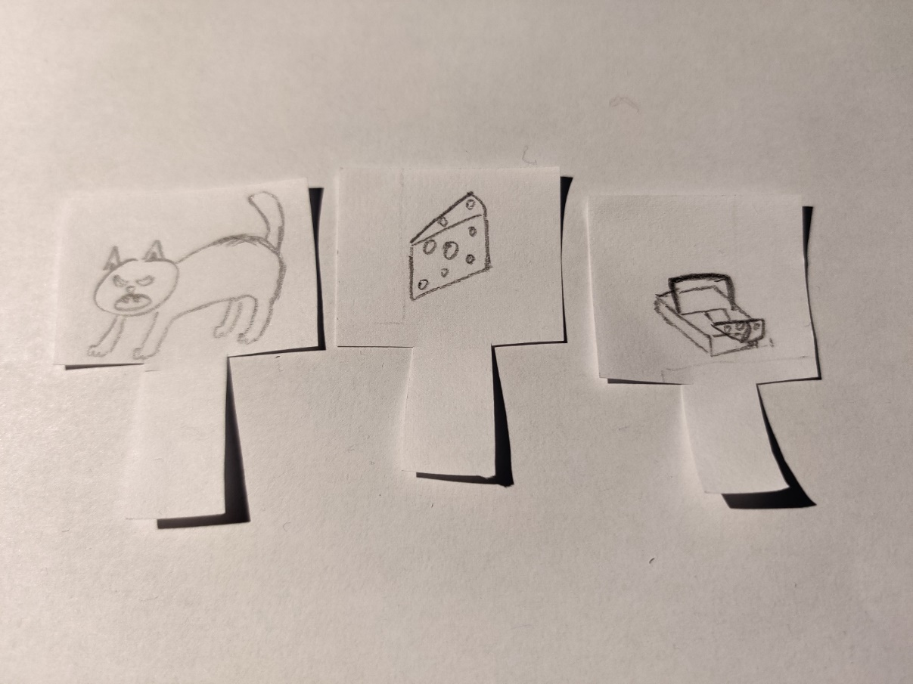

**Asset list link**

<http://www.psdesigns.eu/module-04/asset-list/asset-list.html>

**SMD link**

<https://lucid.app/lucidchart/invitations/accept/d0f09e0c-f86b-42d6-8f37-e0a86e50786d>